“Torch means freedom for the original thinker, the conscientious scholar, the responsible critic and honest dissenter.”

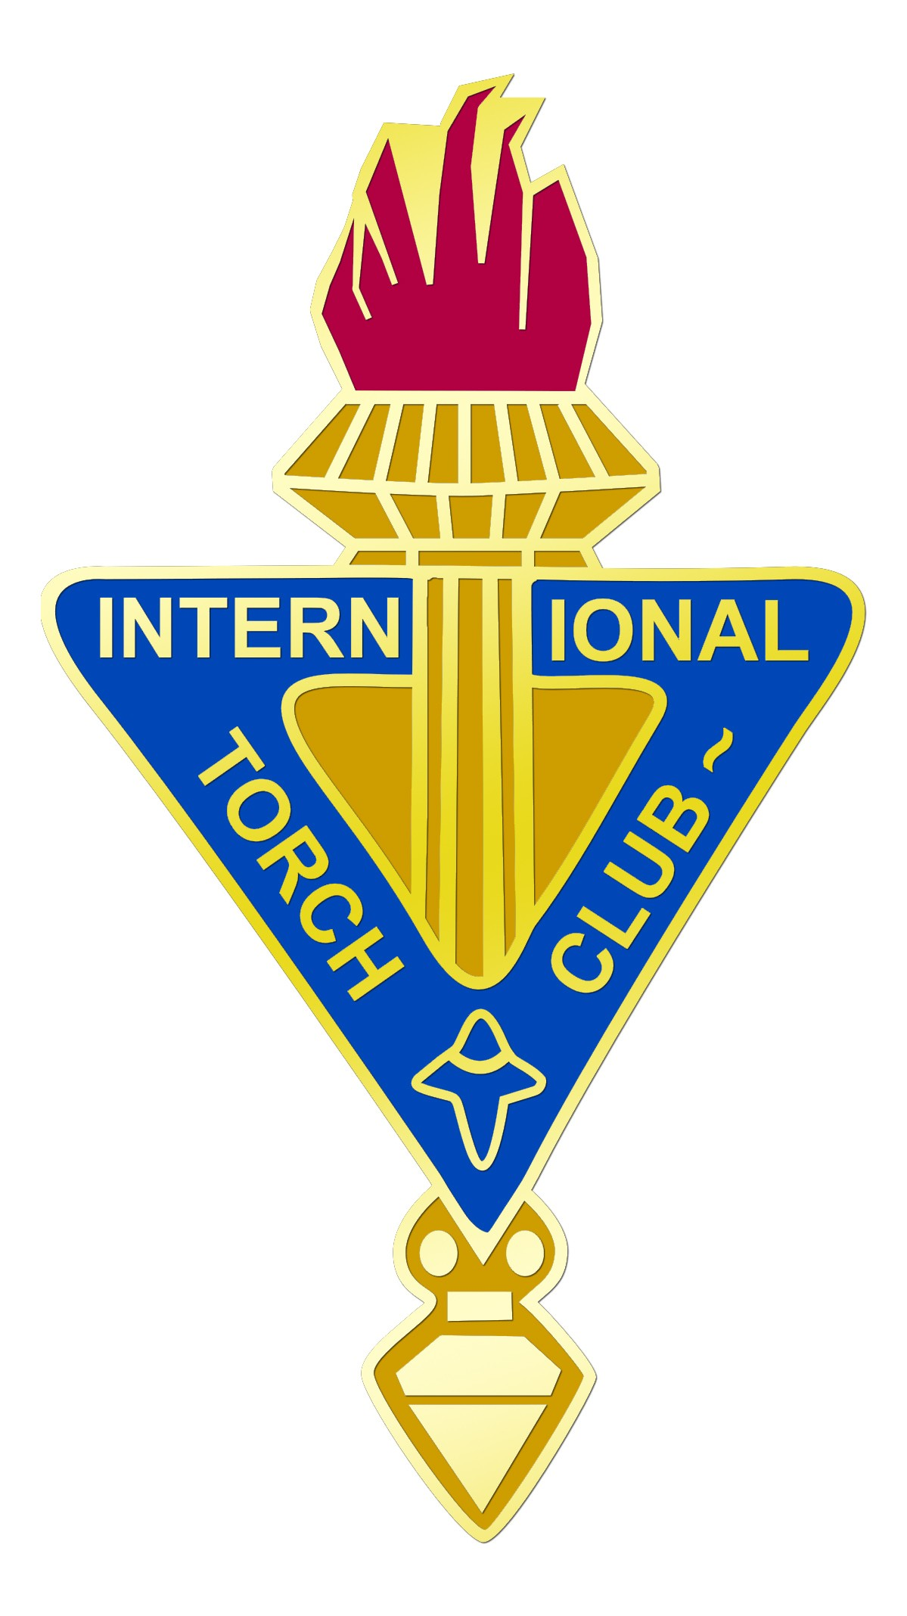

“If our free society is to survive, we must use wisely all our resources. And the most valuable of these are in the minds and spirits of free men. It is for this reason that intellectual freedom emerges as the First Value of Torch”

Leonard C. Kerchner
Past President
International Association of Torch Clubs
1957-58

The International Association of Torch Clubs offers the following services to Torch Club – Fox Valley
members:

The Torch Magazine
♦ Periodical publication of outstanding
TORCH papers

TORCHLIGHT
♦ Newsletter featuring events and
highlights from the TORCH world

Conventions
♦ Club delegates combine Association
business and social enjoyment with
stimulating program events

Awards Programs
♦ Individual and club achievements are
given recognition

Research & Development
♦ Periodic studies of club practices and
performances

Informational Services
♦ Prompt responses to requests by
phone and mail services

Directory Services
♦ Central registration of memberships
and club directory

Torch Club – Fox Valley

Torch Is…

Torch Club – Fox valley

Torch is:

Interacting in a congenial setting with people from other professions

Listening to stimulating papers on subjects of current interest

Discussing these papers with people from other spheres of interest and experience

Enjoying fellowship with others while participating in free inquiry and expression

Torch Club – Fox Valley

Torch Club - Fox Valley meets for dinner on the second Thursday of each month. After dinner a member or guest presents a paper, which is followed by a lively discussion.

Torch Club – Fox Valley determines when and where to meet, how many members it wishes to accept, how its affairs are managed, and what dues are required for budgetary needs. We provide our members a free forum for discussion and a congenial atmosphere.

Our Purpose

We offer fellowship among professionals representing a broad range of experience and interests.

Members mutually explore and exchange ideas and knowledge; advance, confirm, and/or challenge opinions; entertain new insights and perspectives; share humor and forge friendships.
Torch represents fellowship, love of inquiry and discussion, and cultivation of free thinking and free expression.

History and Membership

The first Torch Club was organized in 1924. Originally, membership was restricted to “members of the learned professions.” With the emergence of many new professions, the definition of eligibility has been widened to include “other disciplines pursued by a person in a recognized professional manner.” Local Torch Clubs have the right to set their own general boundaries, and membership is open, upon invitation of the club, to those the club deems professional persons of good standing in the community. All local clubs are members of the International Association of Torch Clubs.

Interested in Becoming a Member of Torch Club – Fox Valley?

The very fact that you have received this brochure indicates that you possess the background and credentials we’re looking for in a new member. For further details on membership fees, meeting dates and locations, contact:
Torch Club – Fox Valley President,
Paul Freiberg at Paulfreiberg@hotmail.com .

